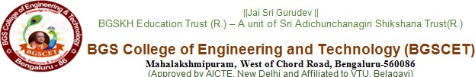
Department of Information Science and Engineering
ZeroOne – _init_to_win_it
24 hours Hackathon
Date: 5th November 2025
Title of the program | ZeroOne -_init_to_win_it_
Venue | ISE Department, BGS College of Engineering and Technology,  Bengaluru.
Date & Time | 5th November 2025, 2:00 PM– 6th November, 2:00 PM
Organizer Details/  Coordinator Details | Convenor –  Dr. Chaitra Naveen, HoD, Department of Information Science and Engineering  Faculty Coordinator-  - Ms. Poojitha K, Asst Prof. , Department of Information Science and Engineering  - Ms. Maheshwari Patil, Asst Prof. , Department of Information Science and Engineering
Jury | Mr. Sumanth C Gowda, Mrs. Vedha C, Dr. Vani V, Mr. Sathisha G, Dr. Madhura Gangaiah, Ms. Vandana S Sardar, Dr. Chandini A G, Mr. Nagraj B Kalligudd
Problem Statement | Reimagine everyday life – Reinvent common experiences or routines through creative application’s of technology.  Everyday Evolution – Apply creativity and technology to evolve how people live, work and interact.
Student Strength of the Session | 84 - 23 Teams
Importance of session | The ZeroOne Hackathon was organized to inspire creativity, collaboration, and innovation among the students within the Information Science and Engineering Department. This session aimed to provide a platform for the young minds to explore how technology can be applied in solving real-world problems and improving everyday life. It involved all semester students from Information Science and Engineering Department, thus encouraging participation in the culture of innovation and problem-solving.  The event was based on the themes "Reimagine Everyday Life" and "Everyday Evolution"; hence, challenging participants to reimagine common experiences and routines through creative applications of technology. This event invoked the spirit of teamwork, critical thinking, and technical curiosity among participants.  ZeroOne provided the students with hands-on learning, collaborative development, and problem-solving in a creative way. The session brought into light the need to translate ideas into meaningful output, showing how imagination and innovation provide the base for every technical advancement.
Outcome/Takeaway | - Students learned how to use technology to solve real-life problems.  - The event encouraged teamwork, creativity, and problem-solving skills.  - Participants gained confidence in sharing and developing new ideas.  - Students understood how small ideas can turn into practical solutions.  - The hackathon created excitement for innovation and hands-on learning.  - It inspired students to think creatively and explore future projects.
Photos | 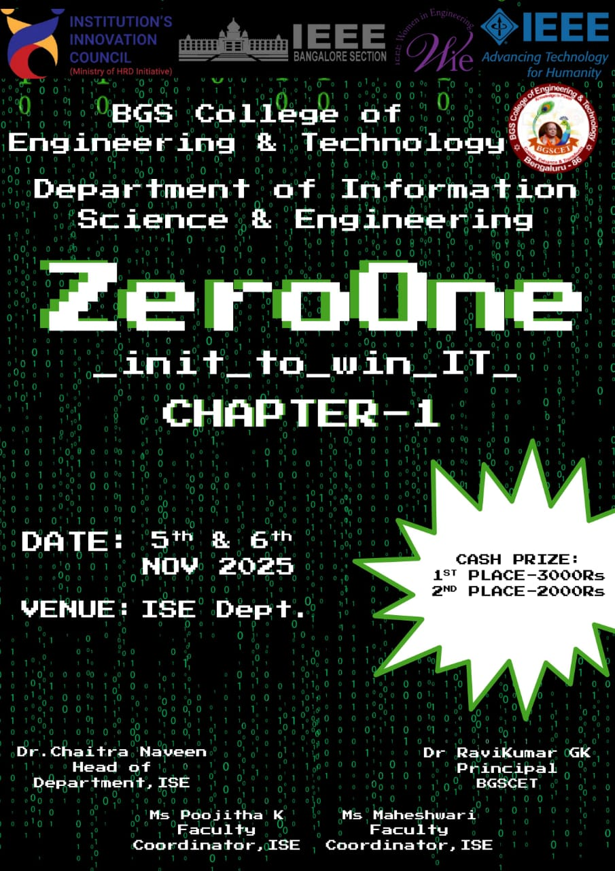  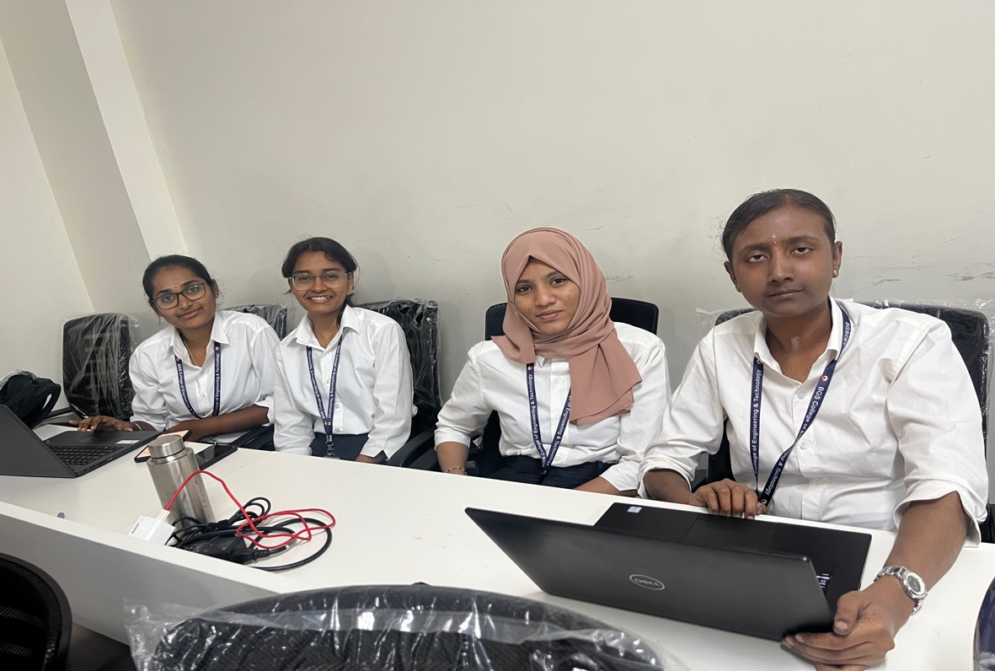  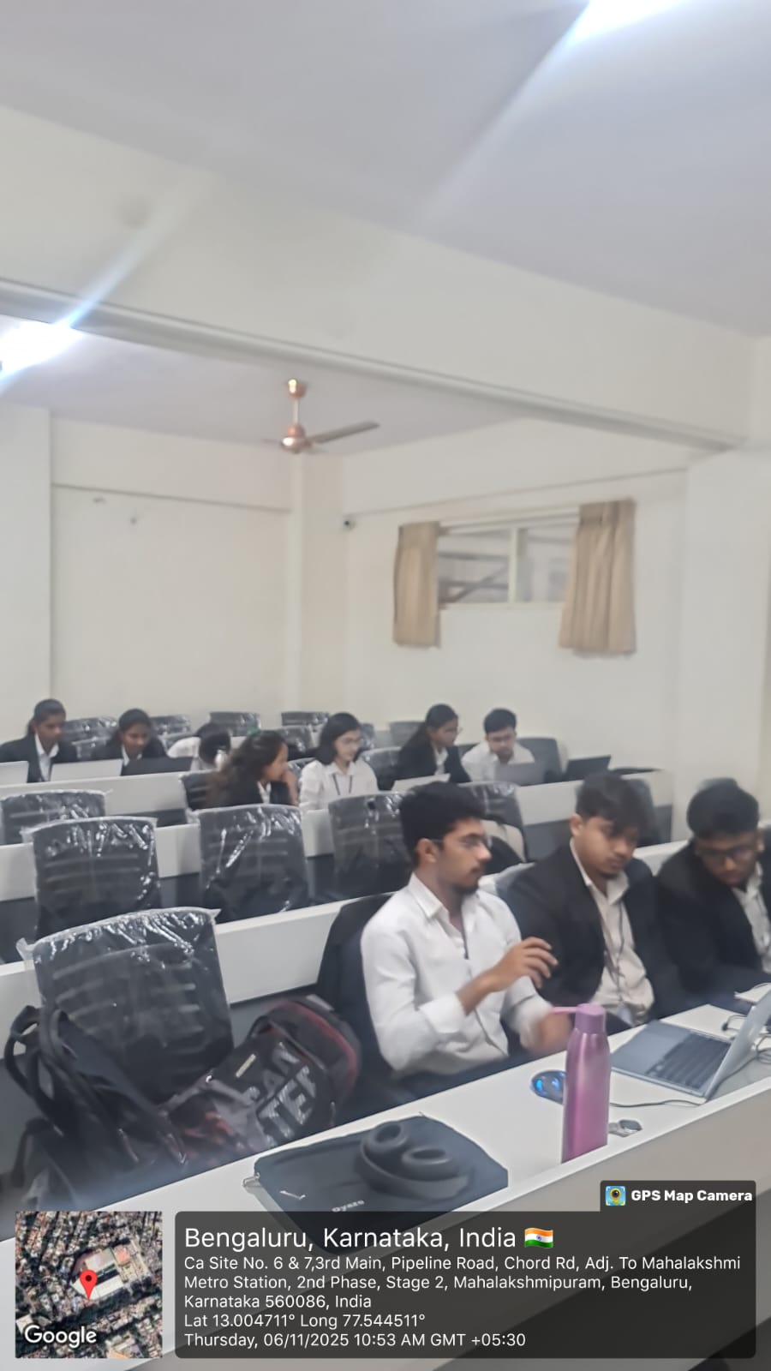  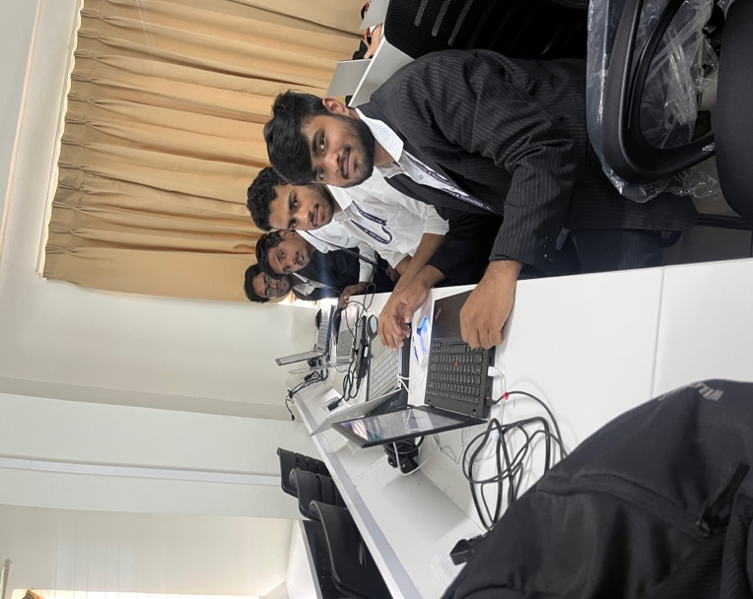  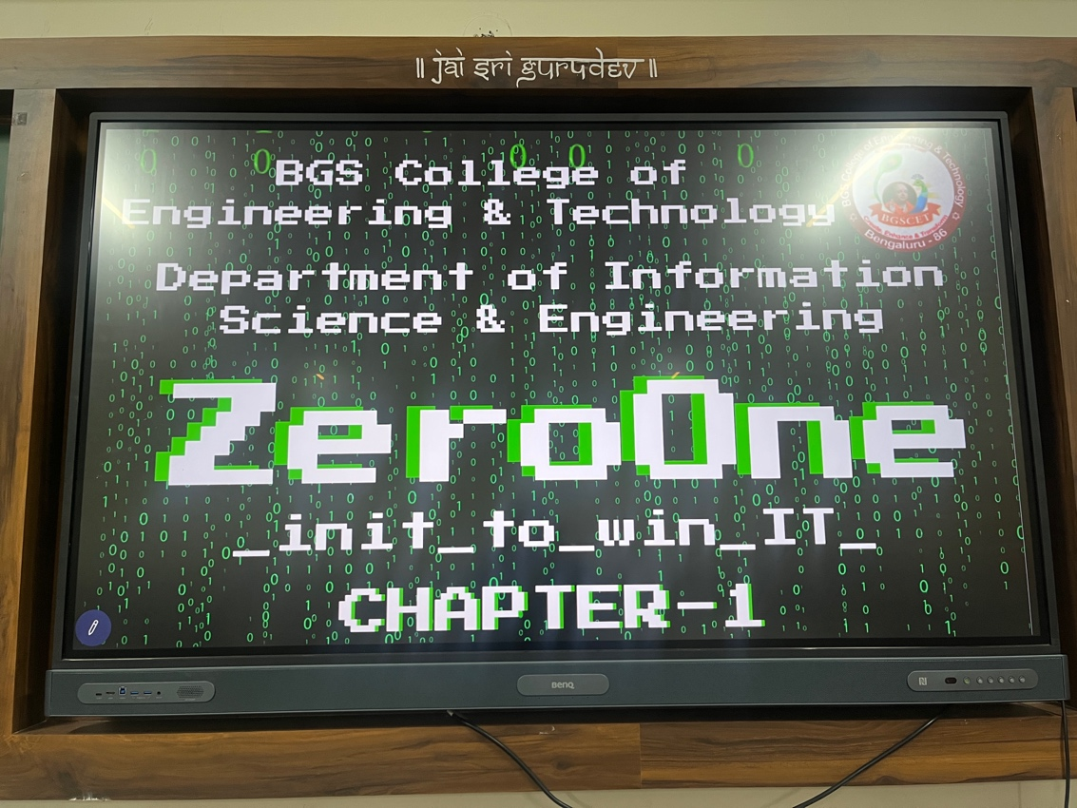

Coordinator Signature of HOD
Ms. Poojitha K Dr. Chaitra Naveen
Ms. Maheswari Patil ISE, BGSCET
ISE, BGSCET

