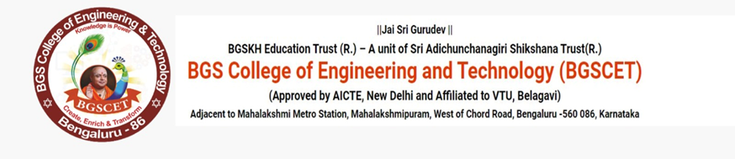
DEPARTMENT OF COMPUTER SCIENCE AND DESIGN

VIDYUT-A 6hr HACKATHON
Date: 31/10/2025

The Department of Computer Science and Design (CSD) organized an exciting and intellectually stimulating 6-hour hackathon titled “VIDHYUTH”, on 31/10/2025 as part of its ongoing efforts to promote innovation, creativity, and problem-solving among students. The hackathon aimed to create an experiential learning environment where students could apply their theoretical knowledge to real-world challenges through collaborative and time-bound project development.
The event provided a platform for students to explore cutting-edge technologies, enhance their teamwork abilities, and develop a spirit of healthy competition. It was also designed to encourage design thinking, rapid prototyping, and innovative solution-building — essential skills for aspiring engineers and technologists.

Objective of the Hackathon
The primary objectives of the VIDHYUTH Hackathon were:
- To promote innovation and creative thinking among students.
- To encourage teamwork and multidisciplinary collaboration.
- To bridge the gap between classroom learning and real-world problem-solving.
- To foster a startup culture and inspire entrepreneurial ideas.
- To enhance coding, design, and presentation skills through hands-on practice.

Event Details
- Event Name: VIDHYUTH – 6-Hour Hackathon
- Organized by: Department of Computer Science and Design
- Duration: 6 Hours
- Total Teams Participated: 22
- Total Participants: Over 80 students
- Venue: 601 and 605
- Date: 31/10/2025

Themes of the Hackathon
Participants were given the freedom to select from three broad and socially relevant themes, designed to spark creativity and practical thinking:
StudentmInnovation
TravelAandALogistics
EdTech
Highlights and Outcomes
- The hackathon witnessed intense competition and enthusiastic participation from all 22 teams.
- Students showcased exceptional creativity, with projects ranging from AI-based campus assistance systems to intelligent route planners and smart education tools.
- The mentoring sessions by faculty experts helped participants refine their ideas and overcome technical challenges.
- Several teams demonstrated working prototypes within the short timeframe, highlighting their coding proficiency and problem-solving abilities.
- The event concluded with a presentation ceremony, where top-performing teams were recognized and awarded.

.
- 