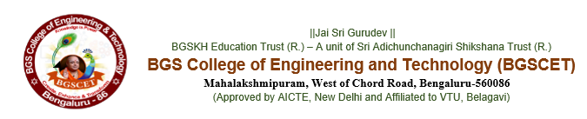

**DEPARTMENT OF COMPUTER SCIENCE AND DESIGN**

|  |  |
| --- | --- |
| **Title of the program** | LINUX Unleashed-Practical Session |
| **Venue** | Lab 405 |
| **Date & Time** | 15/03/2025 |
| **Resource person** | Dr.Dheeraj D, Researcher, ATRIA University |
| **Faculty Coordinators** | Prof Sanjitha |
| **Importance of the Session** | LINUX Commnads |
| **Student Strength of the Session** | 60 |
| **Outcome/Takeaway** | || Jai Sri Gurudev ||  With the Divine Blessings of His Holiness Jagadguru Sri Sri Sri Dr. Nirmalanandanatha Mahaswamiji and the support from Principal Department of Computer Science And Design Organized Hands on Session on LINUX  The hands on Session covered the following Introduction to Linux, Installing Linux, Complete Linux Commands, Basic Linux Commands, Linux File System, File Management in Linux, Searching Files in Linux |