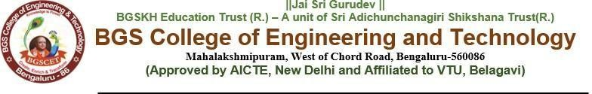

**Detailed Report on MERN Lab Workshop**

**Date:** 20th and 21st March 2025  
**Venue:** Lab-405  
**Organized by:** Department of AI&DS   
**Target Audience:** 4th Semester Students

**Introduction**

A comprehensive hands-on workshop on the MERN (MongoDB, Express.js, React.js, and Node.js) stack was conducted for the 4th-semester students as per the VTU syllabus. The primary objective of the workshop was to provide students with practical exposure to full-stack web development, enhancing their understanding of both frontend and backend integration.

**Objectives**

* To introduce students to the fundamentals of the MERN stack and its applications.
* To provide hands-on experience in developing web applications using MongoDB, Express.js, React.js, and Node.js.
* To enhance students’ understanding of database management, API development, and frontend design.
* To equip students with industry-relevant skills in modern web development.
* To bridge the gap between theoretical concepts and real-world application.

**Workshop Schedule & Highlights**

**Day 1(Morning): Introduction to MERN Stack & Environment Setup**

* Overview of full-stack development and the MERN stack.
* Setting up the development environment (Node.js, MongoDB, Express.js, React.js, VS Code).
* Introduction to version control with Git and GitHub

**Day 1(Afternoon): Backend Development with Node.js and Express.js**

* Understanding server-side programming.
* Setting up an Express.js server.
* Creating RESTful APIs using Express.js.
* Middleware concepts and authentication mechanisms.

**Day 2(Morning): Database Operations with MongoDB**

* Introduction to NoSQL databases and MongoDB.
* CRUD operations (Create, Read, Update, Delete) using MongoDB.
* Connecting MongoDB with Express.js.
* Implementing Mongoose for schema management.

**Day 2(Afternoon): Frontend Development with React.js**

* Introduction to React.js and component-based architecture.
* State management using hooks and context API.
* Routing in React using React Router.
* Connecting the frontend with the backend.

**Hands-on Activities**

During the workshop, students actively engaged in:

* Setting up and configuring the MERN stack environment.
* Building a RESTful API and handling CRUD operations.
* Developing a dynamic frontend using React.js.
* Implementing user authentication and authorization.
* Deploying a functional full-stack web application.

**Workshop Outcomes**

* Students gained practical experience with full-stack development.
* Improved understanding of server-client architecture and database management.
* Ability to develop and deploy a full-stack web application independently.
* Strengthened problem-solving and debugging skills.
* Enhanced confidence in working with modern web technologies

**Feedback & Conclusion**

The workshop was highly interactive and engaging, providing students with valuable insights into the MERN stack. Participants appreciated the hands-on approach, which significantly enhanced their learning experience. The feedback collected from students was overwhelmingly positive, with many requesting advanced workshops on MERN stack topics such as micro services, performance optimization, and advanced security techniques.

The successful completion of this workshop has contributed to the skill development of students, aligning with industry requirements and VTU curriculum standards.

|  |  |
| --- | --- |
|  |  |
|  |  |
|  |  |

##### **Faculty Coordinator's HOD Sign**

##### Ms. Sindhu.G & Mr. Manjunatha E C

##### Asst. Prof.

##### Dept. of AI&DS

##### BGSCET