##### ||Jai Sri Gurudev ||

##### BGSKH Education Trust (R.) – A unit of Sri Adichunchanagiri Shikshana Trust(R.)

# **BGS College of Engineering and Technology**

**Mahalakshmipuram, West of Chord Road, Bengaluru-560086**

##### (Approved by AICTE, New Delhi and Affiliated to VTU, Belagavi)

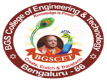

**Information Science & Engineering**

**International Internship and Higher Studies abroad**

Manya - The Princeton Review is a well-known test preparation and admissions counseling company. They offer services to help students prepare for standardized tests such as the SAT, ACT, GRE, GMAT, and more. Additionally, they provide guidance for college and graduate school admissions processes, including assistance with applications, essays, and interviews. Manya - The Princeton Review is recognized for its experienced instructors, comprehensive study materials, and personalized approach to helping students achieve their academic goals.

About this session:

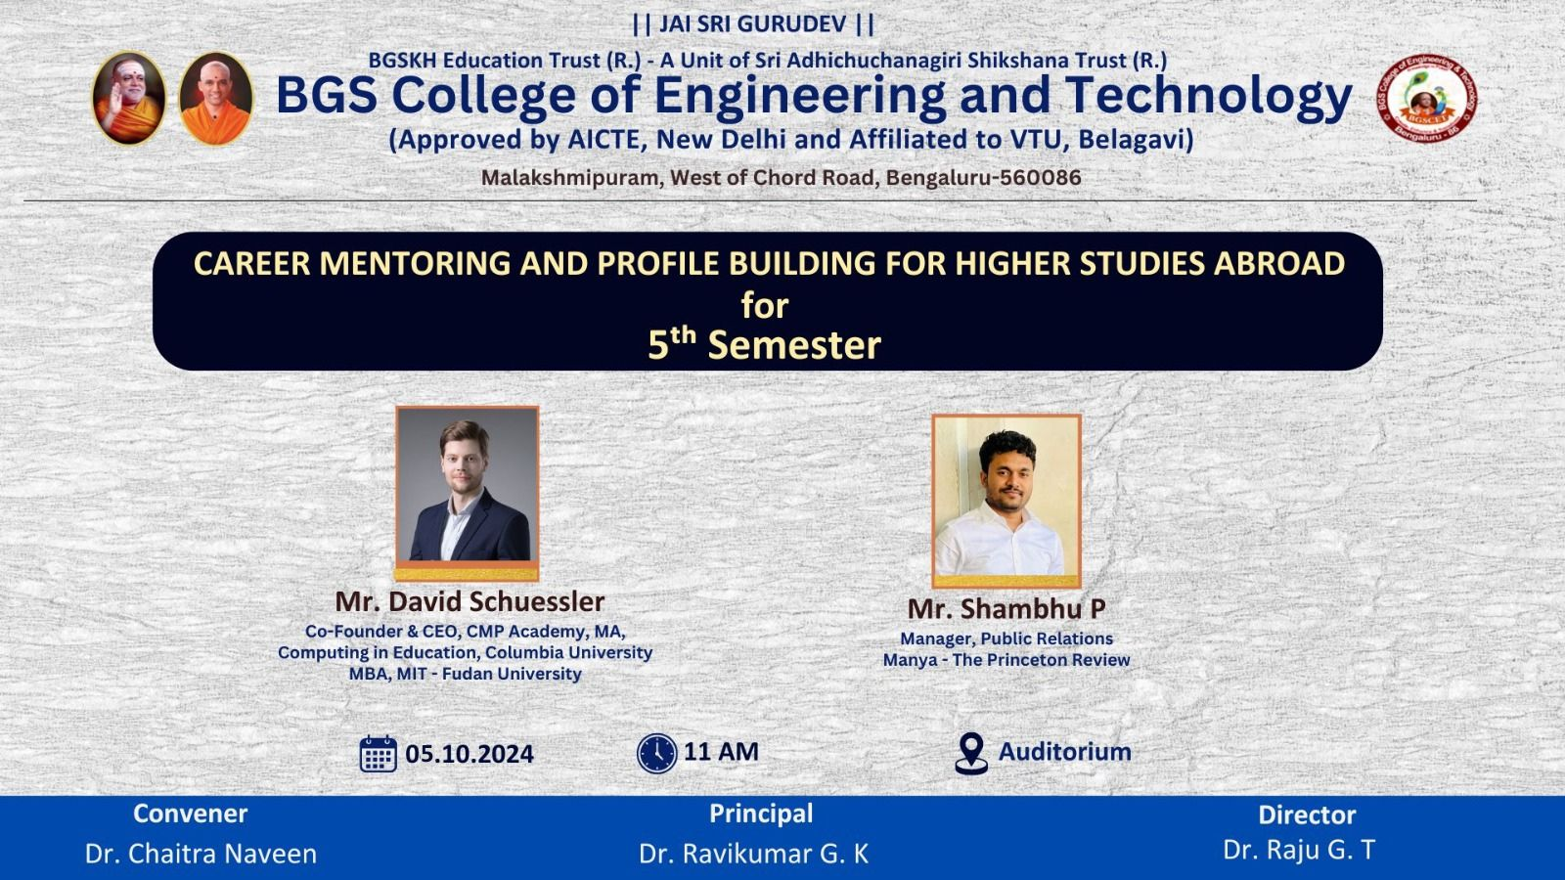

International Internship Program is aiming to guide students to pursue International Internship with Top Universities Professor's across the globe, including scientists, & Nobel laureates, session is mainly aimed to throw lights on how to build a strong profile for getting into Top universities across the globe along with scholarship's assistance for MS while being in India

